The Cupbearer
& The Baker
“Joseph Interprets Dreams” Craft
Two of Pharaoh’s servants had dreams.
With God’s help, Joseph told the
servants what their dreams meant.
Follow Joseph’s path through the dreams.

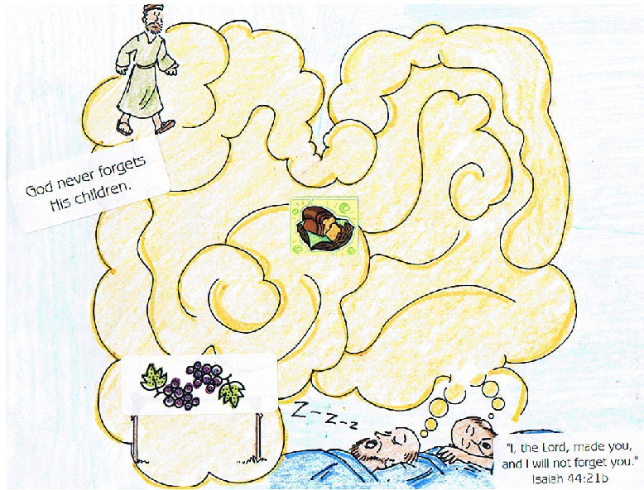

Directions:
- Choose a picture of Joseph and interpreting dreams
- Color picture with crayons
- Draw a line through the path Joseph took to the servants having their dreams
- Apply bread sticker and grapes sticker
- Add Main Point and Key Verse stickers
The Cupbearer
& The Baker
“God Made Me and Will Not
Forget Me” Acorn Craft

Directions:
- Choose an acorn
- Draw face and hair, using markers
- Place completed face in baggy that is labeled with Main Point and Key Verse stickers
- Make several “friends” and remind each other that God never forgets you!

The Cupbearer
& The Baker
“God Made Me and Will Not Forget Me” Magnet Craft

Directions:
- Choose a magnetic frame, www.orientaltrading.com, 57/1505
- Decorate frame with stickers, glitter pens and markers
- Add Main Point and Key Verse stickers
- Add a picture of yourself!

